**EE1004 Exam 2023-24 Semester A**

Question 1 (35 marks)

Researchers are interested in the mean age of a certain population. A random sample of 10 individuals drawn from the population of interest has a mean of 27.

(a) Assuming that the population is approximately normally distributed with standard deviation of 4.5, can we conclude that the mean is different from 30 years at 5% level of significance? Justify whether you should use z-score or t-distribution, and whether this is a one-tailed or two-tailed test. Clearly state your null hypothesis and alternative hypothesis.

(b) What is the largest and smallest value of sample mean that would result in acceptance of null hypothesis?

Question 2 (20 marks)

A bipartite graph G is one in which the vertices can be split into two disjoint sets A and B such that each edge of G joins a vertex in A with a vertex in B. For the four graphs below, explain which one is bipartite by labelling the vertices as A or B. For the ones which are not bipartite, explain why.

For the graphs which are bipartite, are they complete bipartite graphs? If not, how many edges need to be added to make them complete bipartite graphs?

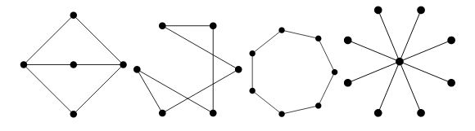

Question 3 (15 marks)

A complete graph with n vertices, denoted by *Kn*, is a simple graph in which each pair of distinct vertices are adjacent.

(a) Explain with derivation how many edges should be there in *Kn*.

(b) Draw *K4* by labelling the vertices as 1, 2, 3, 4 and write down its adjacency matrix.

(c) Draw a subgraph of *K4* having 3 vertices and 2 edges.

Question 4 (15 marks)

(a) Given the following adjacency matrix M of a directed graph, draw the corresponding graph and explain if it is a simple graph with justifications. Can this adjacency matrix correspond to an undirected graph? Explain with justifications.

(b) For the same graph, write down its incidence matrix (denoting an edge between vertex A & B as (A,B) and so on).

|  |  |  |  |  |  |
| --- | --- | --- | --- | --- | --- |
|  | A | B | C | D | E |
| A | [0 | 1 | 1 | 0 | 0 |
| B | 1 | 0 | 0 | 1 | 1 |
| C | 0 | 0 | 0 | 0 | 1 |
| D | 0 | 0 | 1 | 0 | 1 |
| E | 1 | 0 | 0 | 0 | 1] |

Question 5 (15 marks)

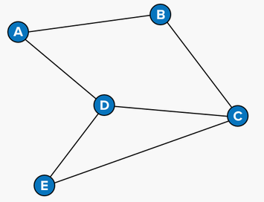

(a) Given the above graph, which of the following are valid walks? Explain with justifications.

A 🡪 B🡪 E🡪 C🡪 D

C🡪 D🡪 A🡪 E🡪D

E🡪 D🡪 C🡪 B🡪 A

B🡪 C🡪 D🡪 B🡪 A

(b) What is the longest trail you can find in the above graph starting from A? What if the starting vertex is D? Show with explanation.

(c) For the graph below, find a path that starts at H, visits **two** other vertices, and then reaches B. Enter each vertex as a capital letter, separated by commas. Now find a path that starts at H, visits **four** other vertices, and then reaches B. Enter each vertex as a capital letter, separated by commas.

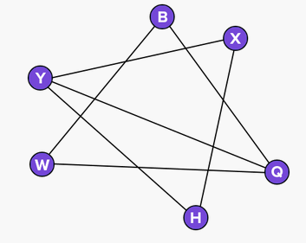

**Solutions:**

Question 1

(a) (20 marks)

z-score used since population s.d. given. (2 marks)

Null hypothesis is H0: μ=30 (2 marks)

Alternative hypothesis is HA: (1 marks)

Two-tailed test since mistake can be made if sample mean is significantly larger or smaller than hypothesized population mean. (2 marks)

n=10, σ=4.5, α=0.05, $\overline{x}=27$

Hence, $z=\frac{\overline{x}- μ}{σ/\sqrt{n}}=-\frac{3}{1.42}=$-2.11 (4 marks)

From the z-distribution table, cumulative probability is 0.017. (4 marks)

Since this is a two tailed test, p-value = 0.034. (3 marks)

Since p-value < α, we reject the null hypothesis. (2 marks)

(b) (15 marks)

Since α=0.05, this tells us what can be the total probability on the two tails of distribution beyond the acceptable extreme values.

Hence, there can be probability of 0.025 at the two tails. (4 marks)

From z-distribution table, cumulative probability of 0.025 corresponds to z = -1.96. (5 marks)

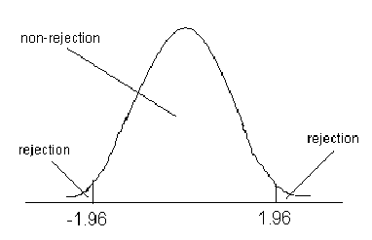

Now, we can work backwards to find acceptable value of $\overline{x} using$ $z=\frac{\overline{x}- μ}{σ/\sqrt{n}}$

Minimum acceptable sample mean = 30 – 2.79 = 27.21 (3 marks)

Maximum acceptable sample mean = 30 + 2.79 = 32.79 (3 marks)

Question 2

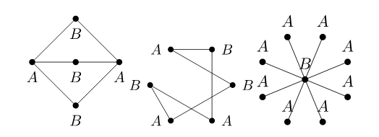

Above 3 are bipartite as shown (4 + 4 + 4 = 12 marks)

The cycle is not bipartite since it has odd number of vertices. If we try to assign alternate vertices to the same group while going around the cycle, we end up with two adjacent vertices with a connecting edge falling in same group. (2 marks)

Let r and s denote the number of vertices in group A and B respectively.

For complete bipartite graph, number of edges is rs.

Graph 1: r=2, s=3, rs = 6 & |E|=6. hence, this graph is complete (2 marks)

Graph 2: r=3, s=3, rs = 9 & |E|=6. hence, need to add 3 edges (2 marks)

Graph 3: r=8, s=1, rs = 8 & |E|=8. hence, this graph is complete (2 marks)

Question 3

(a) nC2 = n(n-1)/2 since we have to choose all possible unique pairs of vertices from n vertices (4 marks)

(b)

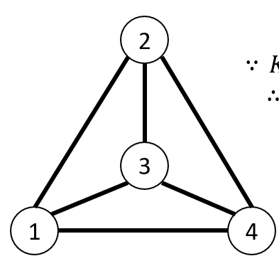 (4 marks)

[0 1 1 1

1 0 1 1

1 1 0 1

1 1 1 0] (4 marks)

(c) Any reasonable answer that has 3 vertices and 2 edges connecting these vertices. (3 marks)

Question 4

This adjacency matrix M cannot belong to undirected graph since it has to be symmetric in that case. (i.e. edge between A & C implies there should be an entry of “1” in location M(1,3) and M(3,1)) (2 marks)

This adjacency matrix has a loop due to a diagonal entry M(5,5) = 1. Hence, it is not a simple graph. (2 marks)

(6 marks)

(b) There are 5 vertices and 10 edges – so the incidence matrix is 5x10

|  |  |  |  |  |  |  |  |  |  |  |
| --- | --- | --- | --- | --- | --- | --- | --- | --- | --- | --- |
|  | (A,B) | (A,C) | (B,A) | (B,D) | (B,E) | (C,E) | (D,C) | (D,E) | (E,A) | (E,E) |
| A | 1 | 1 | -1 | 0 | 0 | 0 | 0 | 0 | -1 | 0 |
| B | -1 | 0 | 1 | 1 | 1 | 0 | 0 | 0 | 0 | 0 |
| C | 0 | -1 | 0 | 0 | 0 | 1 | -1 | 0 | 0 | 0 |
| D | 0 | 0 | 0 | -1 | 0 | 0 | 1 | 1 | 0 | 0 |
| E | 0 | 0 | 0 | 0 | -1 | -1 | 0 | -1 | 1 | 2 |

(5 marks)

Question 5 (15 marks)

(a) E, D, C, B, A is a valid walk because there are edges joining consecutive vertices in this case. In all other cases, one or more edges are absent. (5 marks)

(b)

Starting from A, length of longest trail is 5. E.g. A, B, C, E, D, A (2.5 marks)

Starting from D, length of longest trail is 6. E.g. D, A, B, C, D, E, C (2.5 marks)

(c)

Start at vertex H and choose an edge. What vertex lies at the other end of that edge?

If we start at H and move to X, we can't make it to B with only two more moves. Try moving from H to Y first.

H, Y, Q, B (2.5 marks)

To extend the path, we move to X first and then go to Y.

H, X, Y, Q, W, B (2.5 marks)

**(Other reasonable answers also ok)**